JAVA
Java is a general-purpose programming language was originally developed by Sun Microsystem which was initiated by James Gosling and released in 1995. Java is guaranteed to be Write Once, Run Anywhere (WORA).
- Object Oriented − In Java, everything is an Object. Java can be easily extended since it is based on the Object model.
- Platform Independent − Unlike many other programming languages including C and C++, when Java is compiled, it is not compiled into platform specific machine, rather into platform independent byte code. This byte code is distributed over the web and interpreted by the Virtual Machine (JVM) on whichever platform it is being run on.
- Simple − Java is designed to be easy to learn. If you understand the basic concept of OOP Java, it would be easy to master.
- Secure − With Java's secure feature it enables to develop virus-free, tamper-free systems. Authentication techniques are based on public-key encryption.
- Architecture-neutral − Java compiler generates an architecture-neutral object file format, which makes the compiled code executable on many processors, with the presence of Java runtime system.
In C programming, int data type occupies 2 bytes of memory for 32-bit architecture and 4 bytes of memory for 64-bit architecture. However, it occupies 4 bytes of memory for both 32 and 64-bit architectures in Java.
- Portable − Being architecture-neutral and having no implementation dependent aspects of the specification makes Java portable. Compiler in Java is written in ANSI C with a clean portability boundary, which is a POSIX subset.
- Robust − Java makes an effort to eliminate error prone situations by emphasizing mainly on compile time error checking and runtime checking.
- Multithreaded − With Java's multithreaded feature it is possible to write programs that can perform many tasks simultaneously. This design feature allows the developers to construct interactive applications that can run smoothly.
- Interpreted − Java byte code is translated on the fly to native machine instructions and is not stored anywhere. The development process is more rapid and analytical since the linking is an incremental and light-weight process.
- High Performance − With the use of Just-In-Time compilers, Java enables high performance.
- Distributed − Java is designed for the distributed environment of the internet.
- Dynamic − Java is considered to be more dynamic than C or C++ since it is designed to adapt to an evolving environment. Java programs can carry extensive amount of run-time information that can be used to verify and resolve accesses to objects on run-time.

JVM (Java Virtual Machine) Architecture
JVM (Java Virtual Machine) is an abstract machine. It is a specification that provides runtime environment in which java bytecode can be executed.
JVMs are available for many hardware and software platforms (i.e., JVM is platform dependent).

What is JVM
- A specification where working of Java Virtual Machine is specified. But implementation provider is independent to choose the algorithm. Its implementation has been provided by Oracle and other companies.
- An implementation Its implementation is known as JRE (Java Runtime Environment).
- Runtime Instance Whenever you write java command on the command prompt to run the java class, an instance of JVM is created.

What it does
- Loads code
- Verifies code
- Executes codes
- Provide runtime environment

JVM Architecture
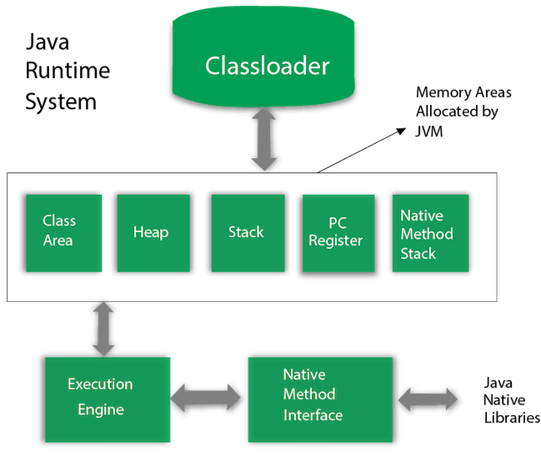

1) Classloader
Classloader is a subsystem of JVM which is used to load class files. Whenever we run the java program, it is loaded first by the classloader. There are three built-in classloaders in Java.
- Bootstrap ClassLoader: This is the first classloader which is the super class of Extension classloader. It loads the rt.jar file which contains all class files of Java Standard Edition like java.lang package classes, java.net package classes, java.util package classes, java.io package classes, java.sql package classes etc.
- Extension ClassLoader: This is the child classloader of Bootstrap and parent classloader of System classloader. It loades the jar files located inside $JAVA_HOME/jre/lib/ext directory.
- System/Application ClassLoader: This is the child classloader of Extension classloader. It loads the classfiles from classpath. By default, classpath is set to current directory. You can change the classpath using "-cp" or "-classpath" switch. It is also known as Application classloader.

2) Class(Method) Area
Class(Method) Area stores per-class structures such as the runtime constant pool, field and method data, the code for methods.

3) Heap - It is the runtime data area in which objects are allocated.

4) Stack - Java Stack stores frames. It holds local variables and partial results, and plays a part in method invocation and return. Each thread has a private JVM stack, created at the same time as thread.
A new frame is created each time a method is invoked. A frame is destroyed when its method invocation completes.
5) Program Counter Register - contains the address of the Java virtual machine instruction currently being executed.

6) Native Method Stack - contains all the native methods used in the application.

7) Execution Engine
- A virtual processor
- Interpreter: Read bytecode stream then execute the instructions.
- Just-In-Time(JIT) compiler: It is used to improve the performance. JIT compiles parts of the byte code that have similar functionality at the same time, and hence reduces the amount of time needed for compilation. Here, the term "compiler" refers to a translator from the instruction set of a Java virtual machine (JVM) to the instruction set of a specific CPU.

8) Java Native Interface
Java Native Interface (JNI) is a framework which provides an interface to communicate with another application written in another language like C, C++, Assembly etc. Java uses JNI framework to send output to the Console or interact with OS libraries.

Data Types
Data Type | Default Value | Default size
boolean | False | 1 bit
char | '\u0000' | 2 bytes
byte | 0 | 1 byte
short | 0 | 2 bytes
int | 0 | 4 bytes
long | 0L | 8 bytes
float | 0.0f | 4 bytes
double | 0.0d | 8 bytes

Q) Why Java is not 100% Object-oriented?
Because of Primitive data types namely: boolean, byte, char, int, float, double, long, short
we have wrapper classes which actually “wrap” the primitive data type into an object of that class.
Q) Why pointers are not used in Java? Mostly asked in java interview questions and Answers in MNC to check your basic knowledge of java and programming languages and logics behind them.
1) They are unsafe.
2) Increases the complexity of the program and since Java is known for its simplicity of code, adding the concept of pointers will be contradicting.
3) Since JVM is responsible for implicit memory allocation, thus in order to avoid direct access to memory by the user, pointers are discouraged in Java

